**Assignment - 19**

**1. What are the data types used in VBA?**

Computer cannot differentiate between the numbers (1,2,3..) and strings (a,b,c,..). To make this differentiation, we use Data Types.

VBA data types can be segregated into two types

* **Numeric Data Types**

| **Type** | **Storage** | **Range of Values** |
| --- | --- | --- |
| Byte | 1 byte | 0 to 255 |
| Integer | 2 bytes | -32,768 to 32,767 |
| Long | 4 bytes | -2,147,483,648 to 2,147,483,648 |
| Single | 4 bytes | -3.402823E+38 to -1.401298E-45 for negative values 1.401298E-45 to 3.402823E+38 for positive values. |
| Double | 8 bytes | -1.79769313486232e+308 to -4.94065645841247E-324 for negative values 4.94065645841247E-324 to 1.79769313486232e+308 for positive values. |
| Currency | 8 bytes | -922,337,203,685,477.5808 to 922,337,203,685,477.5807 |
| Decimal | 12 bytes | +/- 79,228,162,514,264,337,593,543,950,335 if no decimal is use +/- 7.9228162514264337593543950335 (28 decimal places) |

* **Non-numeric Data Types**

| **Data Type** | **Bytes Used** | **Range of Values** |
| --- | --- | --- |
| String (fixed Length) | Length of string | 1 to 65,400 characters |
| String (Variable Length) | Length + 10 bytes | 0 to 2 billion characters |
| Boolean | 2 bytes | True or False |
| Date | 8 bytes | January 1, 100 to December 31, 9999 |
| Object | 4 bytes | Any embedded object |
| Variant(numeric) | 16 bytes | Any value as large as Double |
| Variant(text) | Length+22 bytes | Same as variable-length string |

**2. What are variables and how do you declare them in VBA? What**

**happens if you don’t declare a variable?**

Variables are specific values that are stored in a computer memory or storage system. Later, you can use that value in code and execute. The computer will fetch that value from the system and show in the output. Each of the Excel VBA variable types must be given a name.

When declaring variables, you usually use a **Dim** statement

Dim strName As String

If you don't declare a variable, then VBA treats it as a Variant data type that takes the largest space in memory (16 bytes to 22 bytes) when compared to other data types

**3. What is a range object in VBA? What is a worksheet object?**

Range is a property in VBA that helps specify a particular cell, a range of cells, a row, a column, or a three-dimensional range. In the context of the Excel worksheet, the VBA range object includes a single cell or multiple cells spread across various rows and columns.

In VBA, the worksheet object represents a single worksheet that is a part of the workbook's worksheets (or sheets) collection. Using the worksheet object, you can refer to the worksheet in a VBA code, and refer to a worksheet you can also get access to the properties, methods, and events related to it.

**4. What is the difference between worksheet and sheet in excel?**

Sheets and Worksheets from a VBA perspective are definitely not the same.

In essence, all Worksheets are Sheets, but not all Sheets are Worksheets.

There are different types of Sheets:

* Worksheet – the sheet with the gridlines and cells
* Chart – the sheet which contains a single chart

**Worksheet** – A Worksheet is an object which refers to a single worksheet.  Each worksheet is a member of the Worksheets and Sheets collection objects.

**Worksheets** – Worksheets is a collection object which contains all the individual Worksheet objects in a workbook.

**Chart** – A Chart is an object which refers to a single chart

**Sheets** – Sheets is a collection object which contains all the individual Worksheet and Chart sheet objects in a workbook.

**5. What is the difference between A1 reference style and R1C1 Reference**

**style? What are the advantages and disadvantages of using R1C1**

**reference style?**

In the A1 reference style, you have the column name as an alphabet and the row name as a number and when you select the A1 cell that means you are in column A and row 1. But in R1C1 both column and row are in numbers.

The R1C1 reference style is useful if you want to compute row and column positions in macros. In the R1C1 style, Excel indicates the location of a cell with an "R" followed by a row number and a "C" followed by a column number.

**6. When is offset statement used for in VBA? Let’s suppose your current**

**highlight cell is A1 in the below table. Using OFFSET statement, write a**

**VBA code to highlight the cell with “Hello” written in it.**

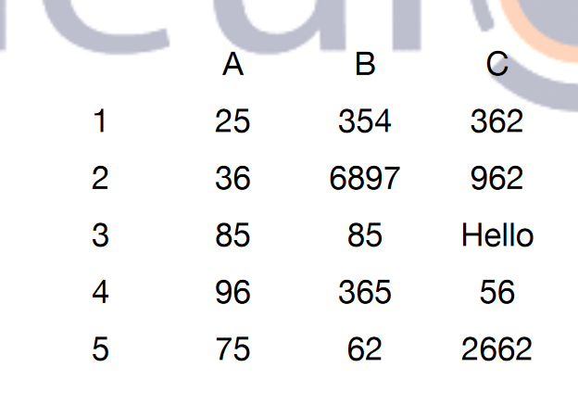

OFFSET can be used with any function expecting a reference argument. The OFFSET function returns a reference to a range that is a specific number of rows and columns from another range or cell. VBA OFFSET is used with RANGE object in VBA.

* VBA code for selecting ‘Hello’ cell

Private Sub CommandButton1_Click()

**Range("A1").Offset(2,2).Select**

End Sub